**Project-Phase-2**

**https://github.com/Punisher22/WebProgramming-Project**

**Implementation of Step2:**

**Modified Project Structure for the phase-1**

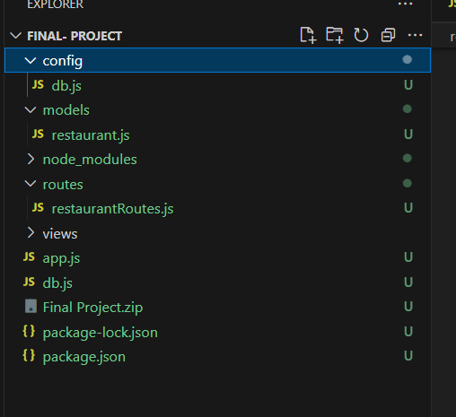

1. Db.js - has all the defined modules
2. Restaurantroutes.js - has all the defined routes
3. App.js - has connection string, db initialization
4. Models- has defined schema named as restaurant.js

**Exploring all the routes:**

1. GET all the restaurants data by using http://localhost:5000/api/restaurants/

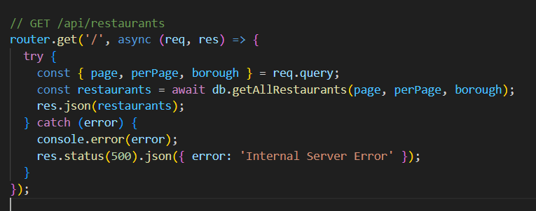

Below is the logic behind the getAllRestaurants module as we have used indexing to parse the whole data because it has a lot of restaurant data. As we run the query we have used the batch to sort the output according to id, page and per page.

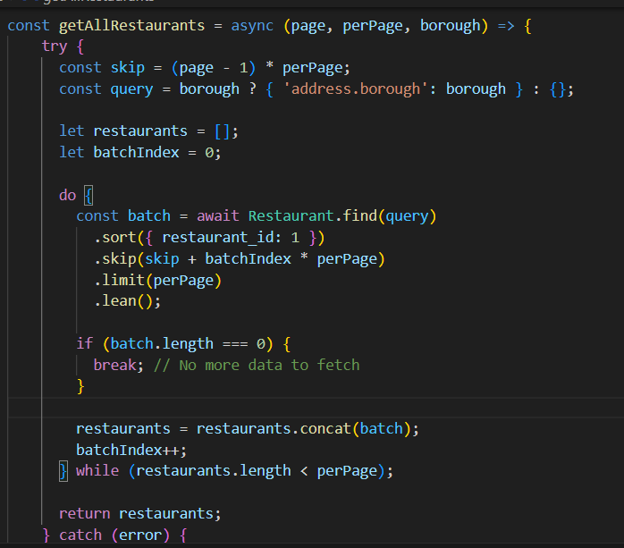

As you can see below, the call is successful, but the response is large so the display is not supported so getting the data in a file.

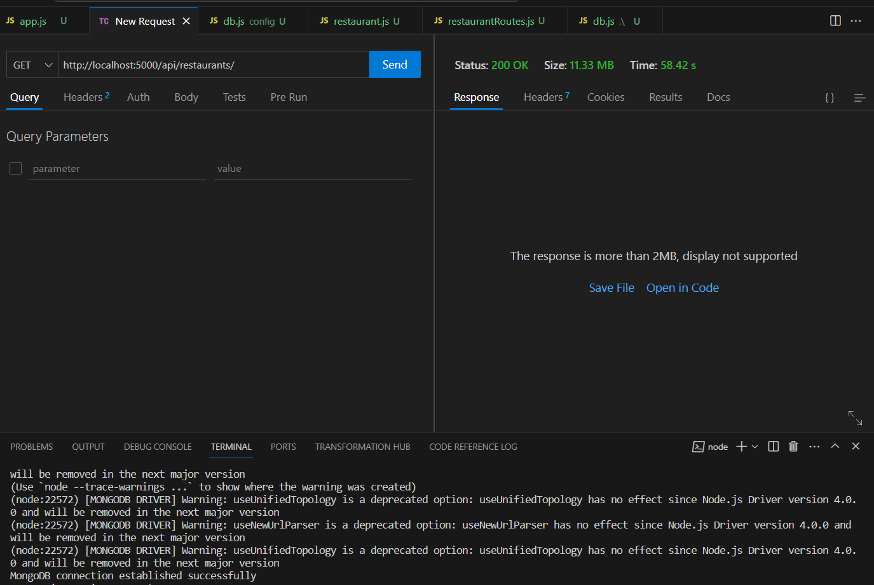

As you can see below I have saved all the restaurants in one file GetAll.txt

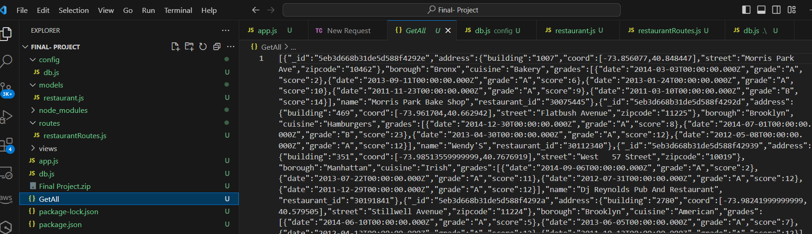

1. GET all the restaurants data by _id using http://localhost:5000/api/restaurants/5eb3d668b31de5d588f4292c

Here I’m using any random _id and below is the response for the particular id

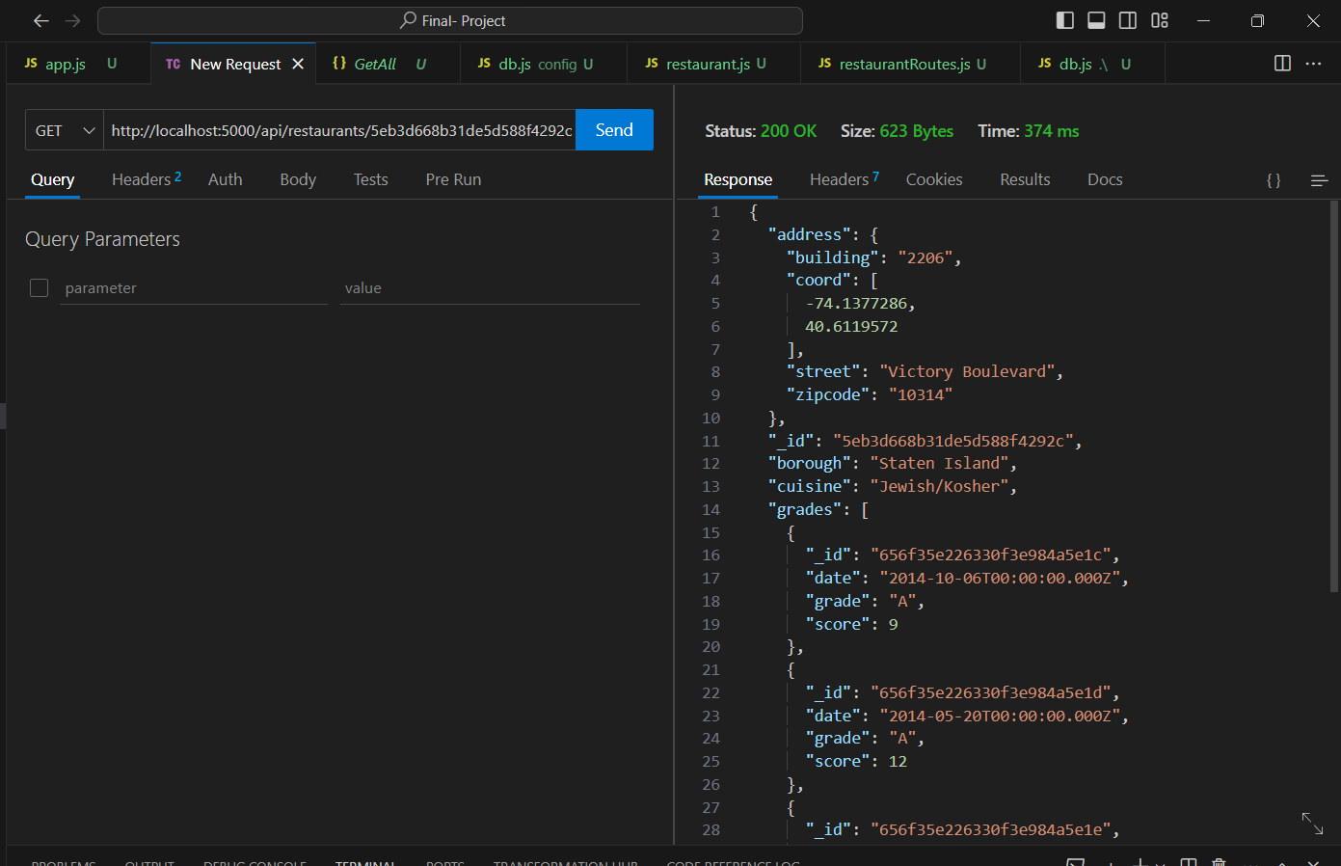

1. GET all the restaurants data by ?page=&perPage= using http://localhost:5000/api/restaurants/?page=1&perPage=5

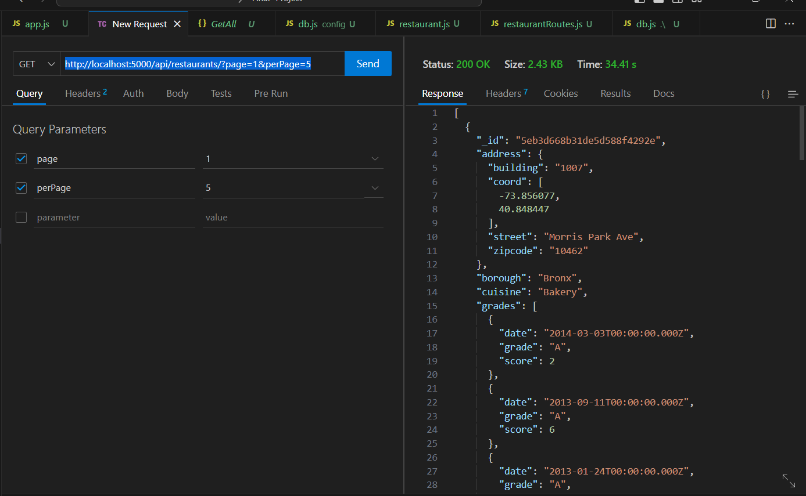

Same way for optional cuisine I have passed bakery for the value and i get the data for that value as well.

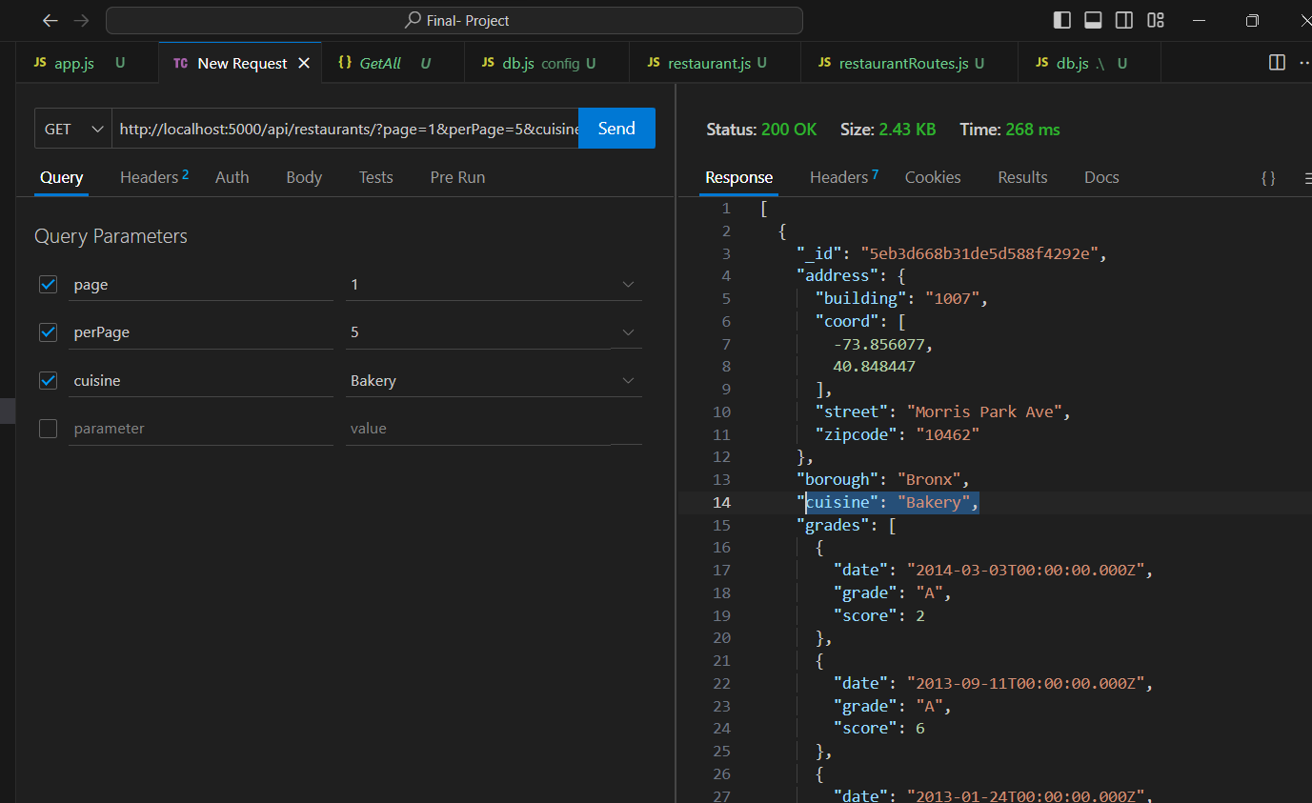

**Now POST Route:**

1. POST

We have used the addNewRestaurant module for this POST route to add the new data.

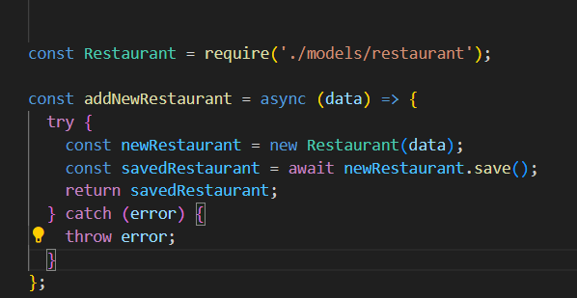

It will use below models/restuarants.js to add the data , we have defined schema here

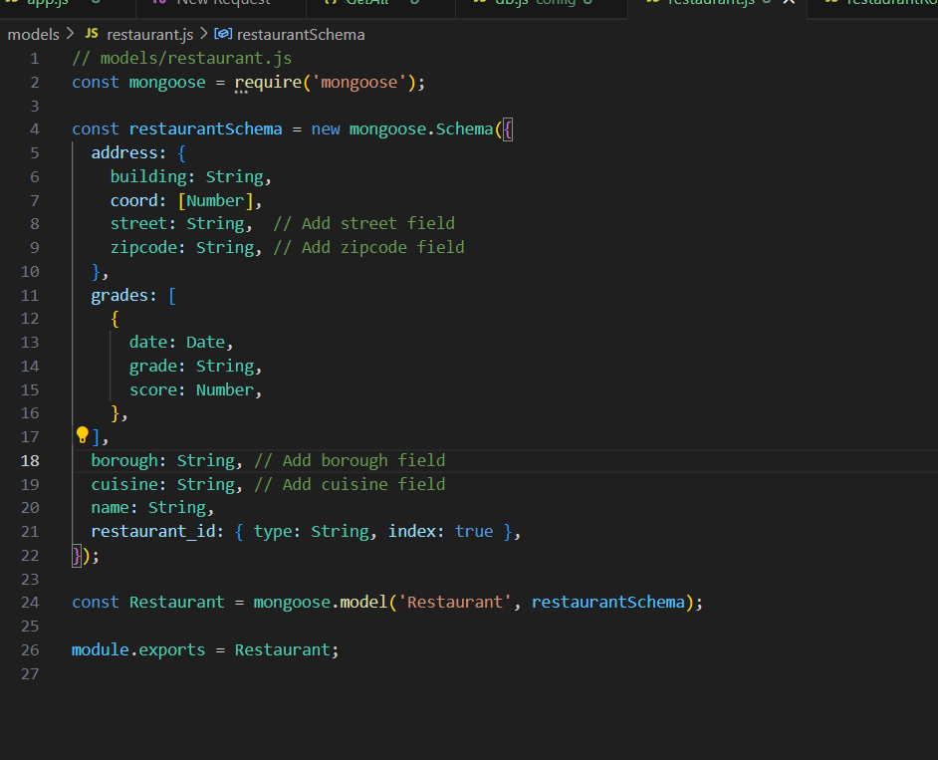

Post Route in the Restaurantsroute.js file

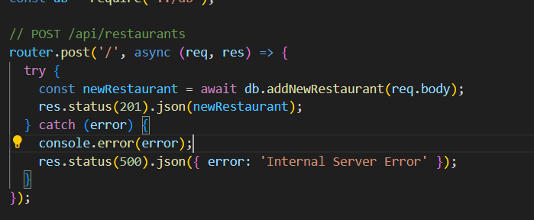

POST

By using POST We’re adding Indian restaurant data into the json format.

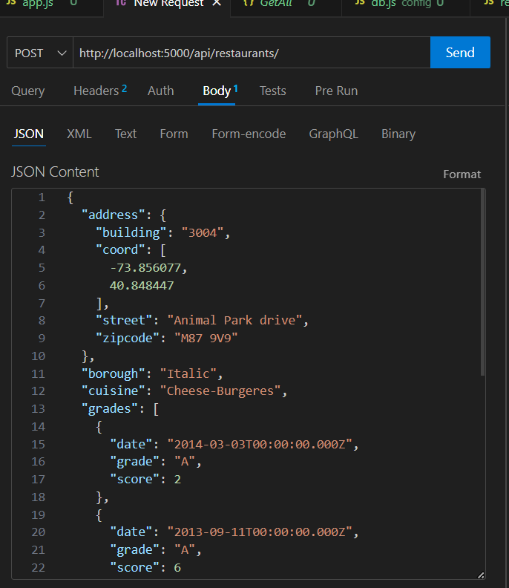

I have italian restaurant data

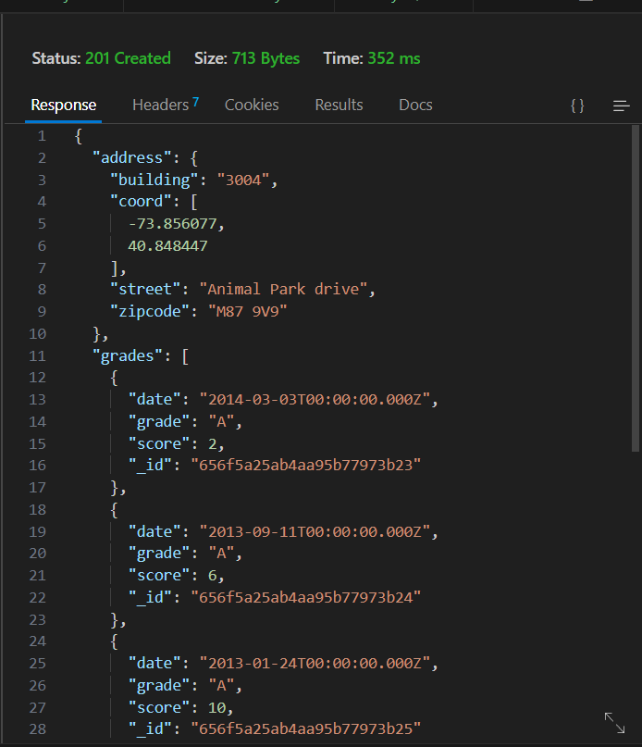

Data has been added successfully

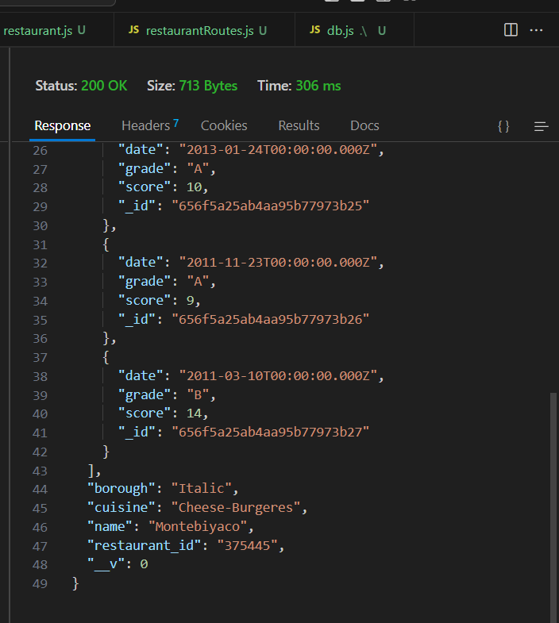

1. PUT:

<http://localhost:5000/api/restaurants/5eb3d668b31de5d588f4292a>

Here is the route function for the updating data that will call db.updateRestaurantbyId

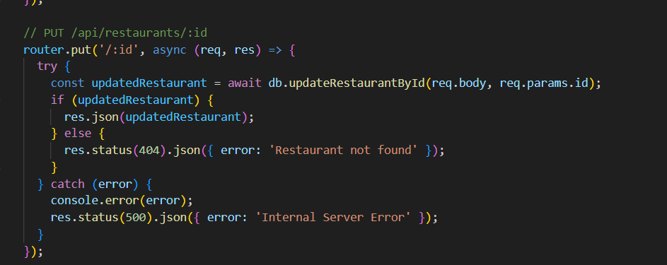

Here it will take body and update by id

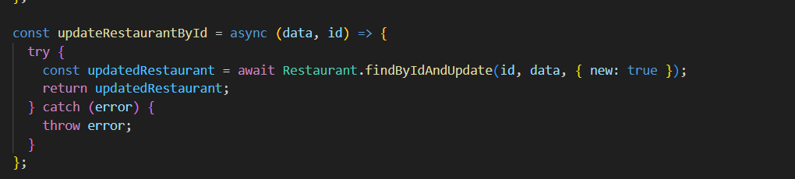

For the below data we’re updating Building number, street, zip code , and cuisine

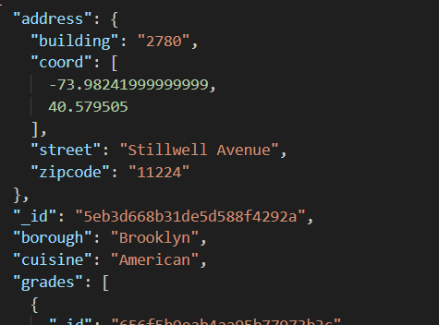

Data has been updated successfully.

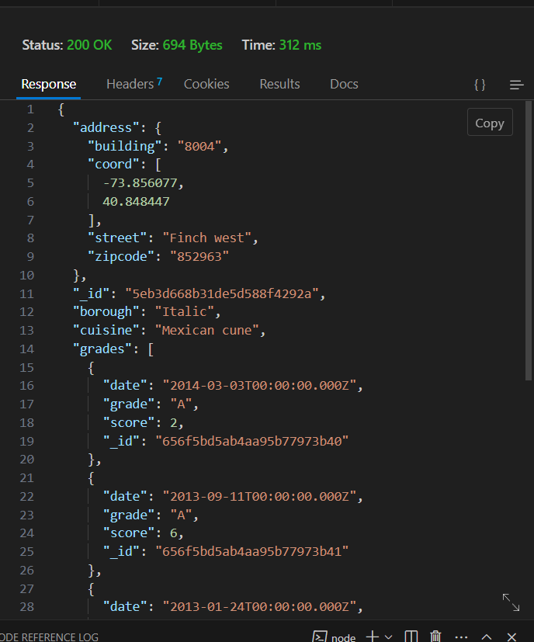

1. DELTE: <http://localhost:5000/api/restaurants/5eb3d668b31de5d588f4292a>  
   Using DELETE by _id deleting the above updated record.

This is the delete route that will call db.deleterestaurantbyid

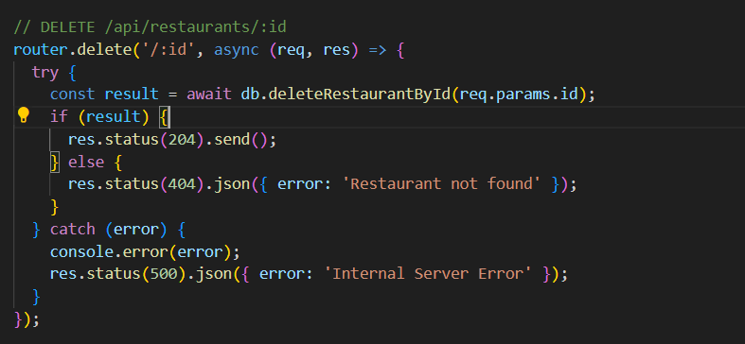

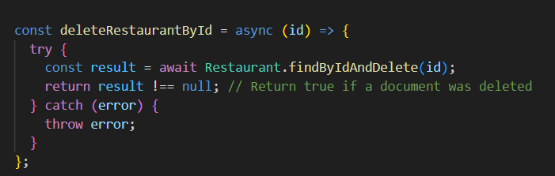

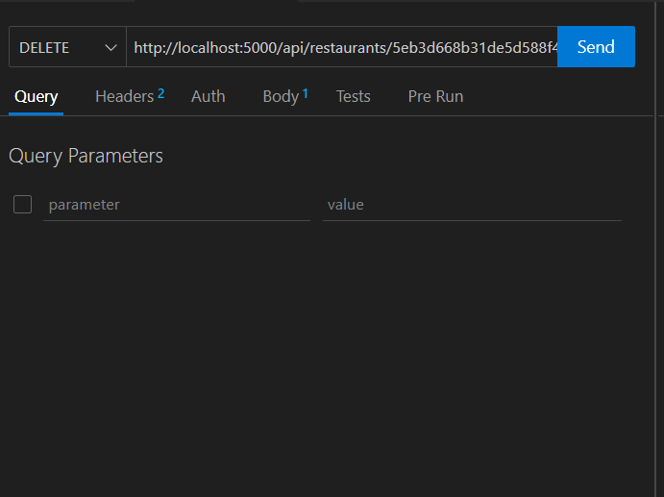

Record deleted successfully not found for the mentioned id

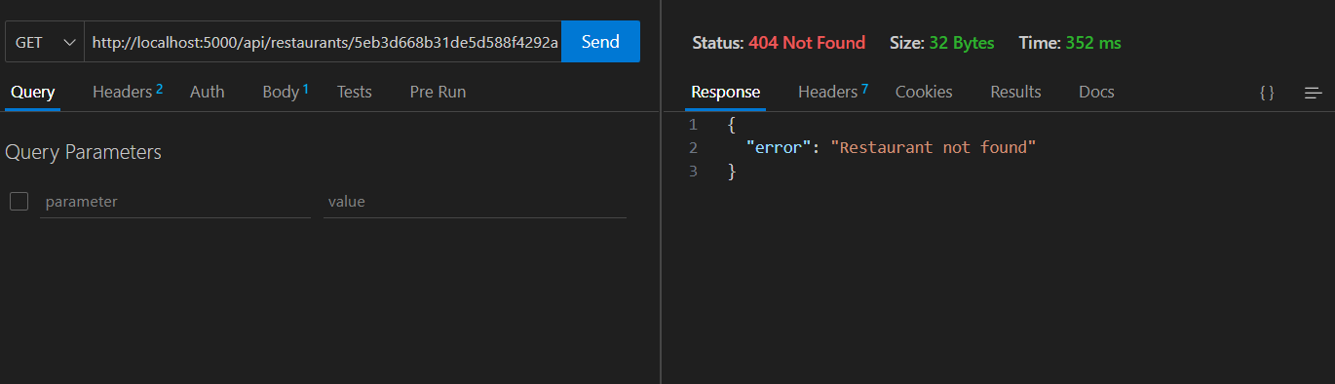

Checked Database record deleted successfully.

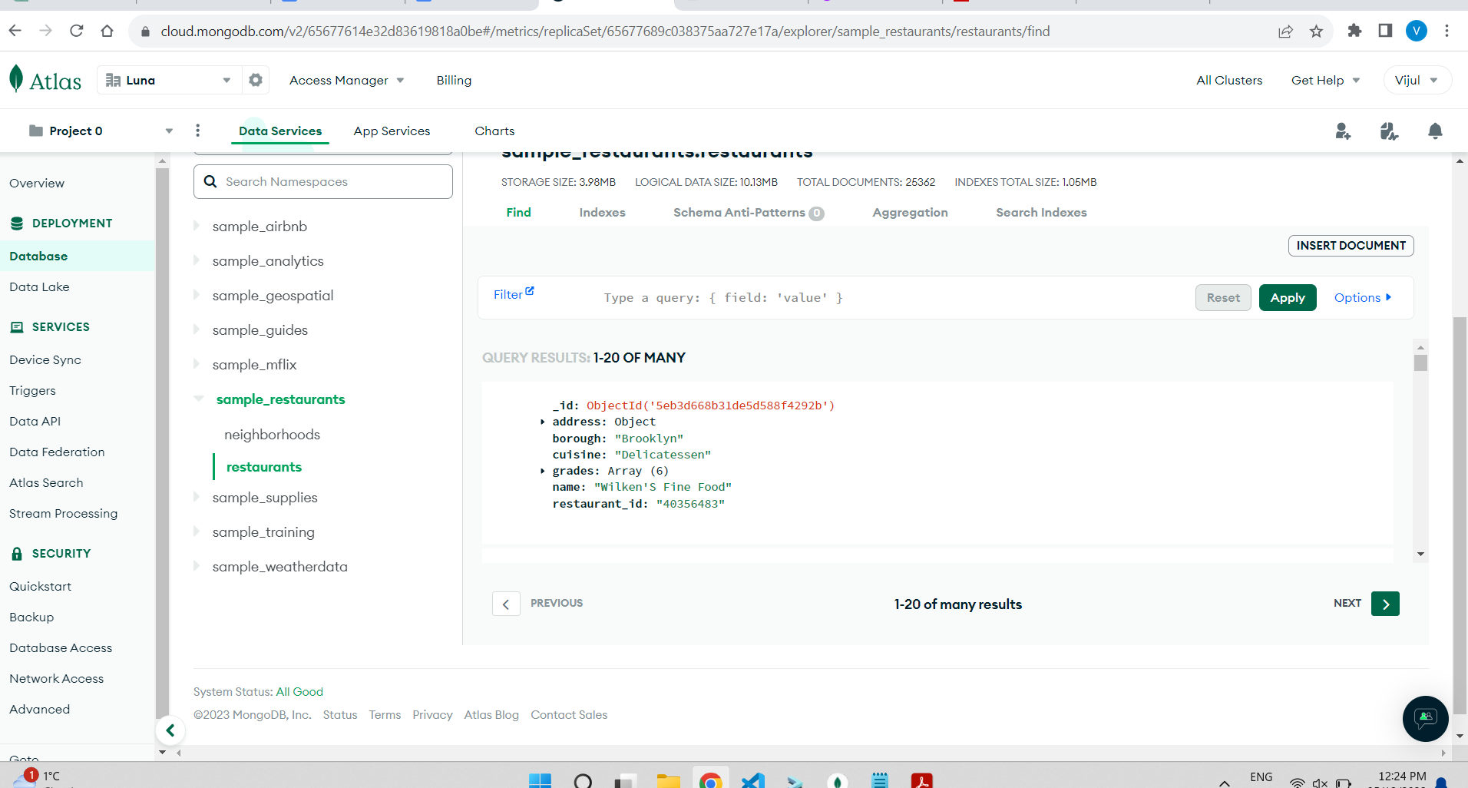

**Security Part:**

**We have added JWT Token authentication while making POST and PUT request.**

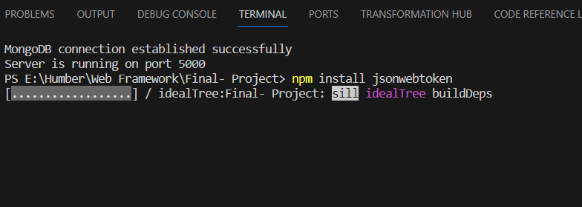

For this ID we’re making PUT request First without token

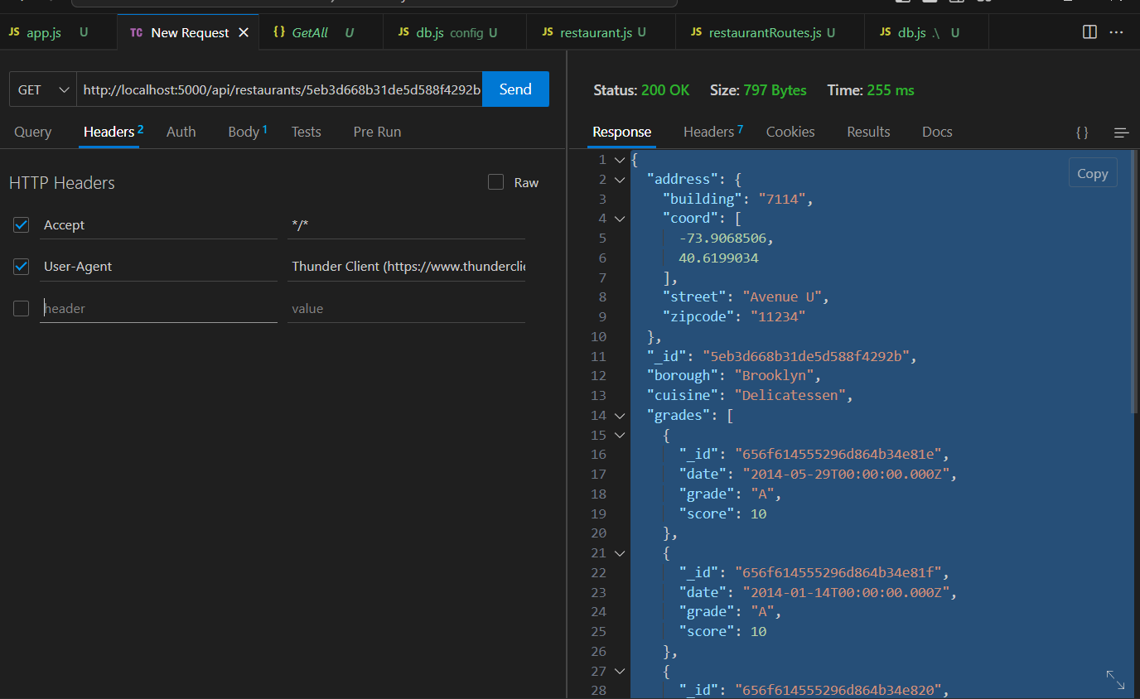

See it clear says unauthorized ,

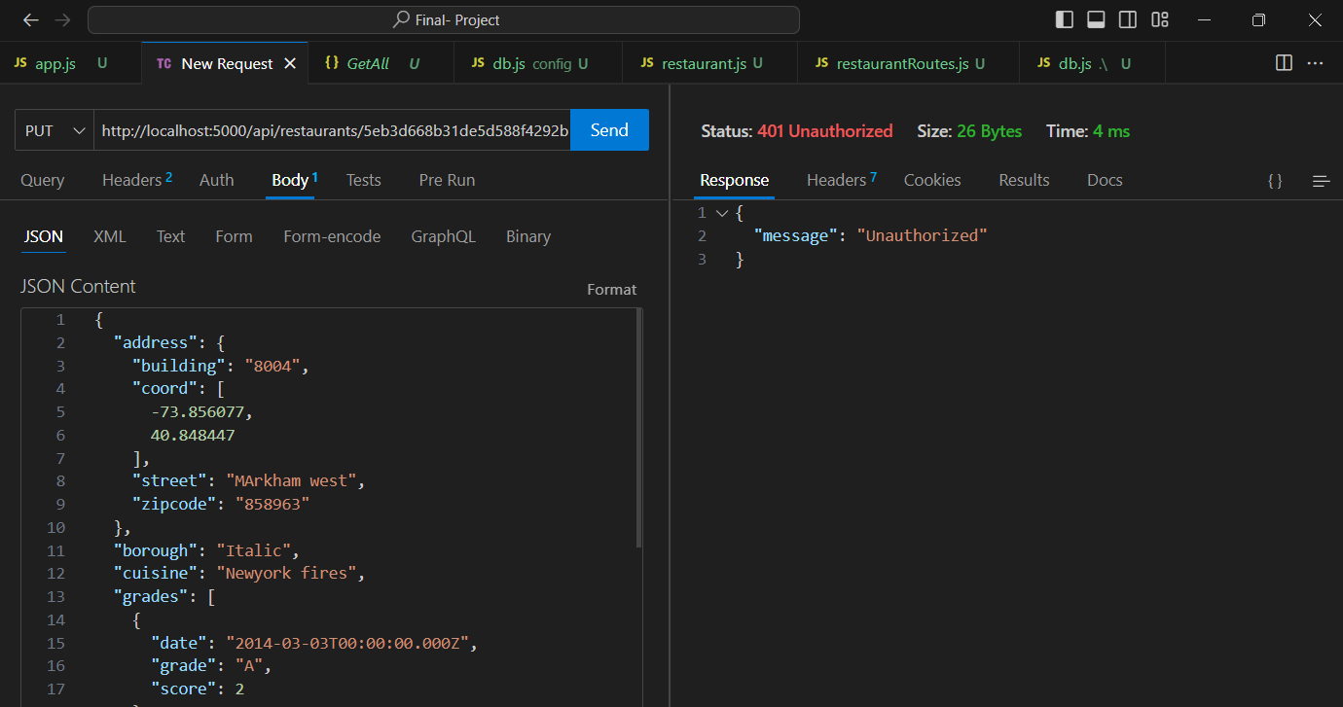

Now making call by passing the Token and we get the updated values.

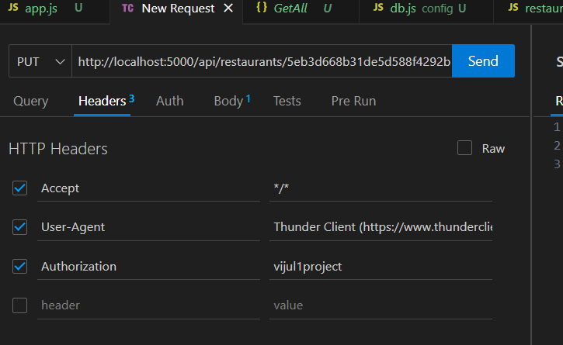

**Phase2 Implementation:**

**Created views:**

Display.hbs

Index.hbs

Login.hbs

Update.hbs

We have implemented A UI

Here by using keywords U can search a restaurant

If user want to check all restaurants then by clicking on see restaurants they can access it.

Now Searching by Name:

Contact us page to contact:

This will lead to WhatsApp account to contact the team.

Login to Update features:

So, for this feature it’s a combination of the Special feature + Security Part

We’re storing the session in the form of cookie that is valid for 1 hour.  
  
and if by mistake user enter the wrong data it will directly show and error that username and password is not valid.

And once it click on the Update restaurants the data will be updated in the db as well.  
  
See below it’s shows that data updated successfully.

Updated in the database as well.

Here you can see that when user enter the false credentials it’s giving the Authentication failed error  
  
